Japan Nuclear Reaction Data Center (JCPRG)

Faculty of Science

Hokkaido University

060-0810 Sapporo, JAPAN

E-mail: services@jcprg.org
Internet: http://www.jcprg.org/
Telephone +81(JPN)-11-706-2684
Facsimile +81(JPN)-11-706-4850

Memo CP-E/124

Date: | October 4, 2007
To: | Distribution
From: | OTSUKA Naohiko
Subject: | JCPRG Progress Report (2006-2007)

The JCPRG Progress Report is attached in this memo to be presented at the NRDC meeting 8-10 October 2007.

Distribution:
S. Babykina, CAJaD | A. Blokhin, CJD | J.H. Chang, KAERI | M. Chiba, JCPRG
S. Dunaeva, NDS | S. Ganesan, BARC | Z.G. Ge, CNDC | O. Gritzay, UkrNDC
A. Hasegawa, NEA-DB | H. Henriksson, NEA-DB | M. Herman, NNDC | A. Kaltchenko, UkrNDC
J. Katakura, JAEA | K. Katō, JCPRG | Y.O. Lee, KAERI | S. Maev, CJD
V.N. Manokhin, CJD | V. McLane, NNDC | A. Mengoni NDS | M. Mikhaylyukova, CJD
A. Nichols, NDS | C. Nordborg, NEA-DB | P. Obložinský, NNDC | Y. Ohbayasi, JCPRG
A. Ohnishi, JCPRG | N. Otuka, JCPRG | V. Pronyaev, CJD | D. Rochman, NNDC
O. Schwerer, NDS | S. Tákacs, ATOMKI | S. Taova, VNIIEF | T. Tárkányi, ATOMKI
V. Varlamov, CDFE | M. Vlasov, UkrNDC | M. Wirtz, NDS | H.W. Yu, CNDC
V. Zerkin, NDS | Y.X. Zhuang, CNDC | EXFOR, NEA-DB

Japan Nuclear Reaction Data Center (JCPRG)
Faculty of Science, Hokkaido University
Steering Committee

Progress Report to the
IAEA Technical Meeting on the Network of Nuclear Reaction Data Centres
8-10 October, 2007
0. General
The “Japan Nuclear Reaction Data Center (JCPRG)” was approved as an organisation of Faculty of Science, Hokkaido University and established on April 1, 2007. In addition to nuclear data activities carried out by JCPRG (Japan-Charged Particle Nuclear Reaction Data Group), the center is concerned with the evaluation of nuclear reaction data in nucleosynthesis in the universe. In order efficiently to compile reaction data obtained by using radioactive ion beam, the center signed a research contract with RIKEN Nishina Center. Education in nuclear data physics is also included in the scope of the center activities. Two researchers in the JAEA Nuclear Data Center are invited to become the visiting professors of the Faculty.
Since the last NRDC meeting (September 2006, Vienna), we have worked on the following activities:

- Reaction data compilation (NRDF and EXFOR)
- Conversion of old NRDF to EXFOR
- Bibliography compilation (CINDA)
- Database maintenance, development and services (NRDF, EXFOR/ENDF and CINDA)
- Development of digitization system (GSYS)
- Customer services

  - Staff
Our activities have been carried out by 13 members (7 postdoctoral researchers, 3 graduate students, 2 undergraduate students and 1 technical staff). They have been supervised by the NRDF Steering Committee, which consists of 10 senior researchers (9 nuclear physicists and 1 information scientist). All activities have been coordinated by 1 secretary.

0.2 Budget
The regular JCPRG budget ended at March 2001. We have been applying to the Japanese government for a competitive budget for our further activity. Last year 4 million JPY was allocated for astrophysical application of nuclear data by Japan Society for the Promotion of Science (JSPS) and an intensive compilation from doctoral theses has been done.

1. Data Compilation (NRDF and EXFOR)
We are continuing data compilation for charged-particle nuclear reaction data obtained in Japan.

1.1 Scope
We are scanning 16 journals for Japanese charged-particle and photo-nuclear nuclear reaction data compilation:
PR/C, PRL, NP/A, PL/B, EPJ/A, NST, JP/G, NIM/A, NIM/B, PTP, JPJ, NSE, ARI, RCA, JRN and JNRS.

1.2 NRDF
From April 2006 to March 2007, CPND and PhND in 45 references (453 records, 1.83 MB) have been newly compiled for NRDF. Usually new data are released at the JCPRG web site several months prior to EXFOR.

1.3 EXFOR
Since the 2006 NRDC meeting, we have made 104 new entries and have revised or deleted 142 old entries. These were transmitted as 18 trans files (E039-E048, J005-J006, K001-K002 and R019-R022) to the NDS open area. JCPRG is grateful for valuable comments from Svetlana Dunaeva and Otto Schwerer (NDS), Stanislav Maev (CJD) and Vladimir Varlamov (CDFE) on our transmissions as always.
According to the agreement (Conclusion 2006-4) at the 2006 NRDC meeting, the scope of area K is defined for photonuclear reaction data from Japan. So far 10 entries were made for data measured at Institute for Nuclear Study, Univ. Tokyo (INS) and National Institute of Advanced Industrial Science and Technology (AIST), and two files (TRANS.K001 and K002) were transmitted to the NDS open area.
Author proof of EXFOR compilation has been made by researchers from ATOMKI, Lawrence Berkeley National Laboratory, Tohoku Univ., JAEA, Konan Univ., RIKEN and KEK.
Compilation of neutron reaction data is outside our compilation scope in principle. But many corrections to neutron entries were proposed by JCPRG in collaboration with JAEA, and revised by the four neutron centres.

1.4 Numerical data input from dissertations
Intensive numerical data compilations have been done. These data were shown in tabular form in dissertations which are (partially) published in Journals. About 30 new entries were compiled from these data. In addition, digitized data of about 10 entries are replaced by these authors’ data. They were partially transmitted in K002. Submission of all other entries will be included in TRANS.E049 and E050.

1.5 NRDF/EXFOR editor
Entries after 2001 have been compiled and revised by our NRDF/EXFOR editor system (HENDEL) including CHEX.

2. Bibliography Compilation (CINDA)
We have prepared CINDA batches for CPND published in Japan every half year. Each batch covers 6 issues of each of 4 Japanese journals JPJ, PTP, NST and JNRS.
Since the 2006 NRDC meeting, two regular batches (49 new lines and 0 modified lines) and a special batch for JENDL-HE2004 (JENDL High Energy File 2004) and JENDL-PD 2004 (JENDL Photonuclear Data File 2004) were prepared and sent to NEA-DB (Reader code J). Bibliographies for neutron induced reaction data in JPJ, PTP, NST and some reports have been compiled by JAEA Nuclear Data Center (Reader code N) as before.

3. Database Maintenance (NRDF, EXFOR/ENDF and CINDA)
We are continuing database maintenance, development and services for NRDF, EXFOR/ENDF and CINDA.

3.1 NRDF (http://www.jcprg.org/nrdf/)
A new web-based NRDF search and plot system on MySQL was released in July, 2007. New compilation, which has been finalized for NRDF, but not for EXFOR, can be obtained from this site. DARPE (another NRDF search and plot system written in Perl) is also available at http://www.jcprg.org/darpe/.

3.2 EXFOR/ENDF (http://www.jcprg.org/exfor/)
EXFOR/ENDF search and plot system is available. This system is written in Perl+MySQL and covers JENDL-3.2 and 3.3, ENDF-B/VI.8 and VII.0, JEFF-3.0 and 3.1, BROND-2.2, CENDL-2 as well as EXFOR.
We have also developed following utilities: PENDL (http://www.jcprg.org/endf/) can output evaluated data libraries in a tabulated form at any temperature and accuracy of interpolation. This is an interface of the ENDF-B Pre-processing codes (PREPRO). Another system RENORM (http://www.jcprg.org/renorm/) is a converter from cross section ratios (e.g. cross section relative to ²³⁵U(n,f) cross section) to absolute cross sections and vice versa using evaluated data libraries as reference cross section sets.

3.3 CINDA (http://www.jcprg.org/cinda/)
We are developing a new search system of CINDA. This is an extension of EXFOR/ENDF search system mentioned above. A preliminary version of the system is available at http://www.jcprg.org/cinda/.

4. Digitization System – GSYS (http://www.jcprg.org/gsys/)
A Java-based digitizing system “GSYS” has been updated and released as GSYS Ver.2.2. Main feature implemented on this release was “Automatic Axis Detection” system, which automatically detects and sets the position of axis by easy operation. It reduced operators’ workload and variation coming from human factors.

5. XML format for nuclear reaction data
We are interested in describing nuclear reaction data in XML (Extensible Markup Language), which might be a common (meta-) format of nuclear reaction data for various libraries (NRDF, EXFOR, ENDF etc.) and enable us to have common bases of softwares.

6. Customer services
We provide Japanese researchers in the fields of nuclear physics and nuclear engineering with nuclear reaction data. For more information, we published “Annual Report of Nuclear Reaction Data File Vol.20” in March 2007 (Japanese + English abstract, http://www.jcprg.org/annual/annual-e.html). We have also issued a list of newly added data into EXFOR every month (http://www.jcprg.org/exfor/info/recentdata.html) in a CINDA like format.
We have received many comments on EXFOR compilation from Japanese users (mainly JENDL evaluators). These comments have been listed to a table (http://www.jcprg.org/exfor/info/feedbacks.html), and forwarded to other centres.

ANNEX: Organization and members of JCPRG

NRDF Advisory Committee
Yasuhisa ABE (Research Center for Nuclear Physics, Osaka Univ., Suita, Osaka)
Yoshinori AKAISHI (RIKEN, Wako, Saitama)
Yasuo AOKI (Univ. of Tsukuba, Tsukuba)
Mamoru BABA (Cyclotron and Radioisotope Center, Tohoku Univ., Sendai)
Junsei CHIBA (Tokyo Univ. of Science, Noda, Chiba)
Akira HASEGAWA (NEA Data Bank, Paris)
Kichiji HATANAKA (Research Center for Nuclear Physics, Osaka Univ., Suita, Osaka)
Masayasu ISHIHARA (RIKEN Nishina Center, Wako, Saitama)
Kiyoshi KATŌ (Hokkaido Univ., Sapporo)
Jun-ichi KATAKURA (Japan Atomic Energy Agency, Tokai)
Mitsuji KAWAI (Kyushu Univ., Fukuoka)
Shigeru KUBONO (Center for Nuclear Study, Univ. of Tokyo, Tokyo)
Shunpei MORINOBU (Research Center for Nuclear Physics, Osaka Univ., Suita, Osaka)
Hiroyoshi SAKURAI (RIKEN Nishina Center, Wako, Saitama)
Tohru MOTOBAYASHI (RIKEN Nishina Center, Wako, Saitama)
Tomofumi NAGAE (Kyoto Univ., Kyoto)
Tetsuo NORO (Kyushu Univ., Fukuoka)
Hajime OHNUMA (Tokyo Institute of Technology, Meguro, Tokyo)
Koichi OKAMOTO (Japan Atomic Industrial Forum Inc., Tokyo)
Hikonojo ORIHARA (Tohoku Institute of Technology, Sendai)
Teijiro SAITOH (Nuclear Science Laboratory, Tohoku Univ., Sendai)
Hajime TANAKA (Hokkaido Univ., Sapporo)
Hiroaki UTSUNOMIYA (Konan Univ., Kobe)

NRDF Steering Committee
Kiyoshi KATŌ (Center Head, Hokkaido Univ., Sapporo)
Shigeyoshi AOYAMA (Niigata Univ., Niigata)
Masaki CHIBA (Sapporo-Gakuin Univ. Ebetsu)
Yoshiharu HIRABAYASHI (Hokkaido Univ., Sapporo)
Toshiyuki KATAYAMA (Hokusei-Gakuen Univ., Sapporo, now at Universität Humburg, Hamburg)
Hiroshi MASUI (Kitami Institute of Technology, Kitami)
Hiroshi NOTO (Hokusei-Gakuen Univ., Sapporo)
Akira OHNISHI (Chairman, Hokkaido Univ., Sapporo)
Shigeto OKABE (Hokkaido Univ., Sapporo)
Hiroyoshi SAKURAI (RIKEN Nishina Center, Wako, Saitama)

NRDF Annual Report Editorial Committee
Yoshiharu HIRABAYASHI (Chairman, Hokkaido Univ., Sapporo)
Hiroshi NOTO (Hokusei-Gakuen Univ., Sapporo)
Ryusuke SUZUKI (Hokkaido Univ., Sapporo)

Staff

- Data Compilation (NRDF and EXFOR):
Takako ASHIZAWA (Hokkaido Univ., Sapporo)
Shin-ya ITO (Hokkaido Univ., Sapporo)
Chikako ISHIZUKA (Hokkaido Univ., Sapporo)
Chie KUROKAWA (Hokkaido Univ., Sapporo)
Hiroshi MATSUMIYA (Hokkaido Univ., Sapporo)
Takaomi MURAKAMI (Hokkaido Univ., Sapporo)
Naohiko OTSUKA (Japan Atomic Energy Agency, Tokai)
Tomoaki TOGASHI (Hokkaido Univ., Sapporo)
Kohsuke TSUBAKIHARA (Hokkaido Univ., Sapporo)
Tooru YOSHIDA (Hokkaido Univ., Sapporo)

2) Bibliography Compilation (CINDA):
Chie KUROKAWA (Hokkaido Univ., Sapporo)
Naohiko OTSUKA (Japan Atomic Energy Agency, Tokai)

3) System Maintenance and Development (NRDF, EXFOR/ENDF, CINDA, GSYS):
Shin-ya ITO (Hokkaido Univ., Sapporo)
Ayumi MINOGUCHI (Hokkaido Univ., Sapporo)
Hirokazu OHMI (Hokkaido Univ., Sapporo)
Naohiko OTSUKA (Japan Atomic Energy Agency, Tokai)
Ryusuke SUZUKI (Hokkaido Univ., Sapporo)

4) Data Services:
Naohiko OTSUKA (Japan Atomic Energy Agency, Tokai)
Hitomi YOSHIDA (Hokkaido Univ., Sapporo)

Secretariat
Hitomi YOSHIDA (Hokkaido Univ., Sapporo)

Office address:
Nuclear Reaction Data Center, Faculty of Science, Hokkaido University
Kita-10 Nishi-8, 060-0810 Sapporo, Japan
Telephone / Facsimile: +81(JPN)-11-706-2684
E-mail: services@jcprg.org Internet: http://www.jcprg.org/

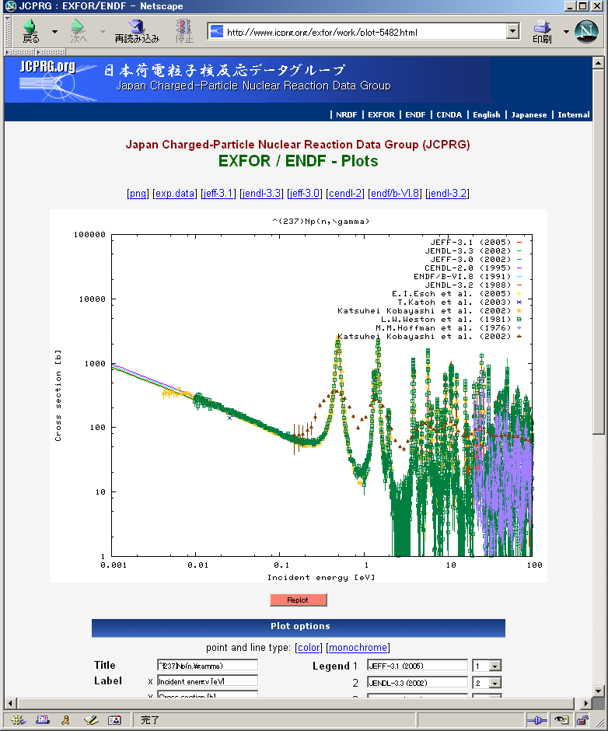
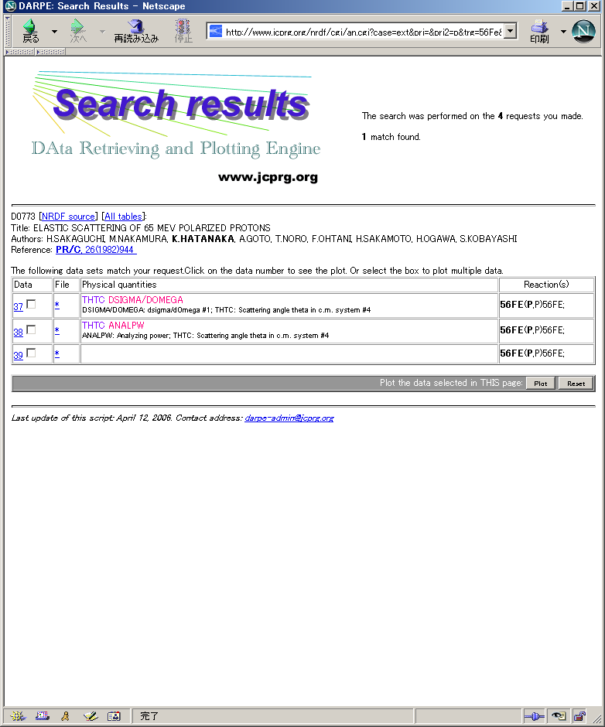
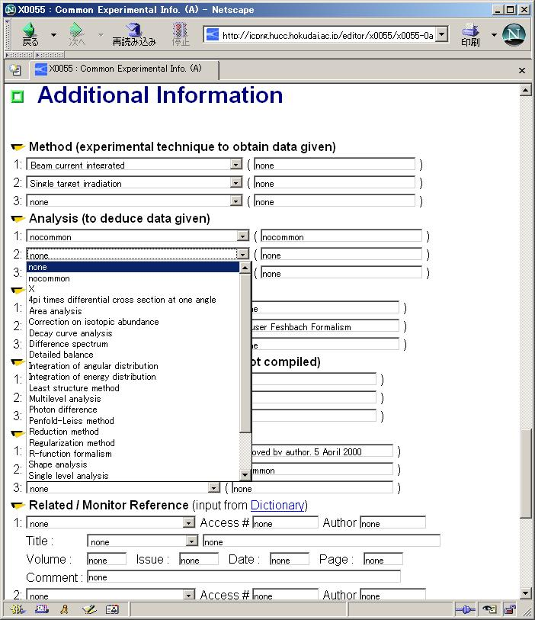
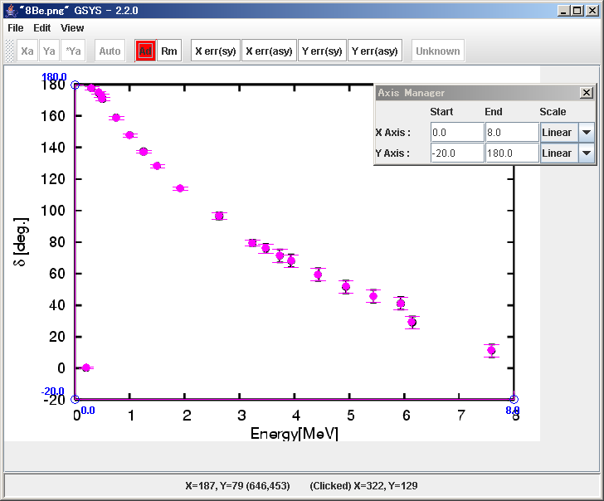
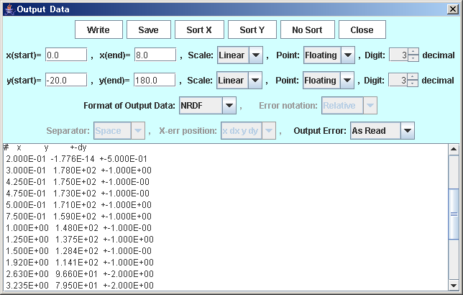
Our Products
NRDF search/plot (DARPE) http://ww.jcprg.org/darpe/

EXFOR/ENDF search/plot
http://www.jcprg.org/exfor/

NRDF/EXFOR editor (HENDEL)
http://www.jcprg.org/hendel/

Digitizer (GSYS Ver.2.2)
http://www.jcprg.org/gsys/

