Japan Charged-Particle Nuclear Reaction Data Group

Division of Physics, Graduate School of Science

Hokkaido University

060-0810 Sapporo, JAPAN

E-mail: services@jcprg.org
Internet: http://www.jcprg.org/
Telephone +81(JPN)-11-706-2684
Facsimile +81(JPN)-11-706-4850

Memo CP-E/123

Date: | October 4, 2007
To: | Distribution
From: | OTSUKA Naohiko
Subject: | ENTRY L0091 correction
Reference | Memo CP-M/23

Excitation functions of (γ,n) reaction and (γ,x+n) on ²³⁸U and ²³²Th compiled in EXFOR are plotted for discussion.

(1) L. Katz et al. define σ(γ,N) as follows:
σ(γ,N) = σ(γ,n) + 2 σ(γ,2n) + … + ν σ(γ,f) + (ν+1) σ(γ,n+f) + …
, and they use σ(γ,N) (not σ(γ,n)) in their captions of Fig.1 to 4.
(2) Above threshold of (γ,2n) (about 11 MeV), both R. Bergere et al. (L0082) and L. Katz et al. (L0091) are coded as (γ,n). R. Bergere’s data show competition with (γ,2n), but Katz’s data do not show it.
(3) Absolute cross section of L. Katz et al. is close to data sets coded as (γ,x+n).

Therefore I would like to support the correction proposed in CP-M/23:
…(G,N)… to …(G,X)0-NN-1

Distribution:
S. Babykina, CAJaD | A. Blokhin, CJD | J.H. Chang, KAERI | M. Chiba, JCPRG
S. Dunaeva, NDS | S. Ganesan, BARC | Z.G. Ge, CNDC | O. Gritzay, UkrNDC
A. Hasegawa, NEA-DB | H. Henriksson, NEA-DB | M. Herman, NNDC | A. Kaltchenko, UkrNDC
J. Katakura, JAEA | K. Katō, JCPRG | Y.O. Lee, KAERI | S. Maev, CJD
V.N. Manokhin, CJD | V. McLane, NNDC | A. Mengoni NDS | M. Mikhaylyukova, CJD
A. Nichols, NDS | C. Nordborg, NEA-DB | P. Obložinský, NNDC | Y. Ohbayasi, JCPRG
A. Ohnishi, JCPRG | N. Otuka, JCPRG | V. Pronyaev, CJD | D. Rochman, NNDC
O. Schwerer, NDS | S. Tákacs, ATOMKI | S. Taova, VNIIEF | T. Tárkányi, ATOMKI
V. Varlamov, CDFE | M. Vlasov, UkrNDC | M. Wirtz, NDS | H.W. Yu, CNDC
V. Zerkin, NDS | Y.X. Zhuang, CNDC | EXFOR, NEA-DB

²³⁸U(γ,n) and ²³⁸U(γ,x+n)

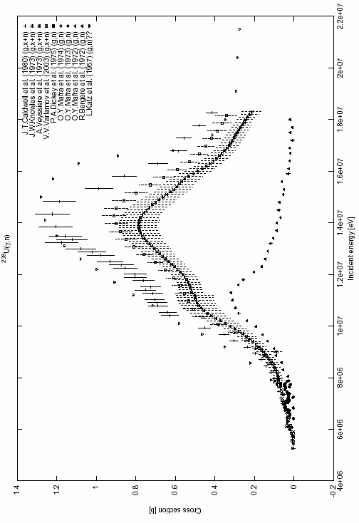

²³²Th(γ,n) and ²³²Th(γ,x+n)
