Japan Charged-Particle Nuclear Reaction Data Group

Division of Physics, Graduate School of Science

Hokkaido University

060-0810 Sapporo, JAPAN

E-mail: services@jcprg.org
Internet: http://www.jcprg.org/
Telephone +81(JPN)-11-706-2684
Facsimile +81(JPN)-11-706-4850

Memo CP-E/106

Date: | December 31 2006
To: | Distribution
From: | SUZUKI Ryusuke and ITO Shinya
Subject: | New version of JCPRG digitizer (GSYS2.2)

A new version of the digitizing software “GSYS2.2” becomes available at the JCPRG website as informed in the last NRDC meeting (C16 in CP-D/472). It should work in computers where the Java Runtime Environment is executable (Windows, Linux, FreeBSD, Macintosh etc.).

What’s new?
1) Automatic axis and scale detection.
2) Popup menu (copy, paste, …) at the text area of output and input numerical data windows.
3) Some other improvements.

Install and uninstall:
1) Install Java Runtime Environment (JRE) Ver. 1.4 or later from http://java.com/.
(Maybe it has been already installed in your computer.)
2) Download “Gsys2.2.0.jar” from http://jcprg.hucc.hokudai.ac.jp/gsys/ver22/gsys-e.html.
3) Double-click “Gsys2.2.0.jar” icon or type “java –jar Gsys2.2.0.jar” from command line.
4) If you want to uninstall GSYS2.2, delete the file “Gsys2.2.0.jar”.

Distribution:
S. Babykina, CAJaD | J.H. Chang, KAERI | M. Chiba, JCPRG | F.E. Chukreev, CAJaD
S. Dunaeva, IAEA-NDS | S. Ganesan, BARC | Z.G. Ge, CNDC | O. Gritzay, KINR
A. Hasegawa, NEA-DB | H. Henriksson, NEA-DB | A. Kaltchenko, KINR | J. Katakura, JAEA
K. Katō, JCPRG | Y.O. Lee, KAERI | S. Maev, CJD | V.N. Manokhin, CJD
V. McLane, NNDC | A. Mengoni IAEA-NDS | M. Mikhaylyukova, CJD | C. Nordborg, NEA-DB
P. Obložinský, NNDC | Y. Ohbayasi, JCPRG | A. Ohnishi, JCPRG | N. Otuka, JCPRG
V. Pronyaev, CJD | D. Rochman, NNDC | O. Schwerer, IAEA-NDS | S. Tákacs, ATOMKI
S. Taova, VNIIEF | T. Tárkányi, ATOMKI | V. Varlamov, CDFE | M. Vlasov, KINR
M. Wirtz, IAEA-NDS | H.W. Yu, CNDC | V. Zerkin, IAEA-NDS | Y.X. Zhuang, CNDC

Automatic axis and scale detection in GSYS2.2 (See CP-E/099 for general usage)
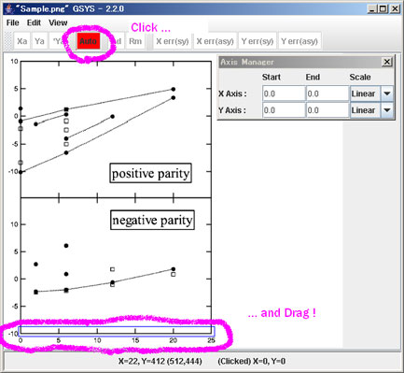
1) Enclose horizontal axis
Click "Auto" button, enclose horizontal axis by dragging, and wait a minute.

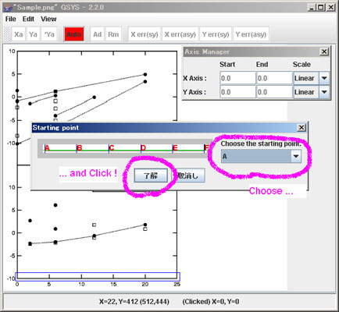
2) Choose start/end points
Choose start and end points on horizontal axis from candidates (A, B, C, …) , and click “OK”.

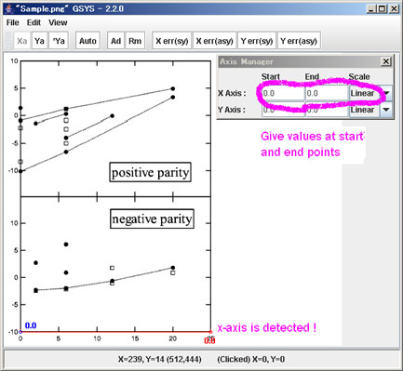
3) Give values and scale
Now horizontal axis and its start and end points are fixed. Then give values of chosen points and scale of axes (linear or logarithmic) in the “Axis Manager” window.

4) Repeat above procedure for vertical axis.

5) Start digitization!

