Japan Charged-Particle Nuclear Reaction Data Group

Division of Physics, Graduate School of Science

Hokkaido University

060-0810 Sapporo, JAPAN

E-mail: services@jcprg.org
Internet: http://www.jcprg.org/
Telephone +81(JPN)-11-706-2684
Facsimile +81(JPN)-11-706-4850

Memo CP-E/099

Date: | August 2 2006
To: | Distribution
From: | OTSUKA Naohiko, SUZUKI Ryusuke, ARAI Koji
Subject: | New version of JCPRG digitizer (GSYS2)

A new version of the JCPRG digitizing software based on java, GSYS2 (GSYS Ver.2) becomes available at the JCPRG website. It should work in computers where the Java Runtime Environment is executable (Windows, Linux, FreeBSD, Macintosh etc.).
Install and uninstall:
1) Go to http://java.com/ and install Java Runtime Environment (JRE) Version 1.4 or later (Maybe it has been already installed in your computer).
2) Go to http://jcprg.hucc.hokudai.ac.jp/gsys/ver2/gsys-e.html and get “Gsys2.jar” (83 kb).
3) Double click “Gsys2.jar”. Then the “Start up window” comes.
4) If you want to uninstall the software, delete “Gsys2.jar”.
What’s new?
1) Users can load numerical data into the system and put them on the image. It enables us to refine numerical data (move, add and delete symbols).
2) Various new options are offered, e.g. output format (number of digits, fixed or floating point etc.). Users can save their preference in your property file.
3) Lower (upper) error bar automatically appears when users click the upper (lower) side of error bars. This helps user to catch the central position of symbols certainly.

Distribution:
S. Babykina, CAJaD | J.H. Chang, KAERI | M. Chiba, JCPRG | F.E. Chukreev, CAJaD
S. Dunaeva, IAEA-NDS | Z.G. Ge, CNDC | O. Gritzay, KINR | A. Hasegawa, JAEA
H. Henriksson, NEA-DB | A. Kaltchenko, KINR | J. Katakura, JAEA | K. Katō, JCPRG
Y.O. Lee, KAERI | S. Maev, CJD | V.N. Manokhin, CJD | V. McLane, NNDC
A. Mengoni IAEA-NDS | M. Mikhaylyukova, CJD | C. Nordborg, NEA-DB | P. Obložinský, NNDC
Y. Ohbayasi, JCPRG | A. Ohnishi, JCPRG | N. Otuka, JCPRG | V. Pronyaev, CJD
D. Rochman, NNDC | O. Schwerer, IAEA-NDS | S. Tákacs, ATOMKI | S. Taova, VNIIEF
T. Tárkányi, ATOMKI | V. Varlamov, CDFE | M. Vlasov, KINR | M. Wirtz, IAEA-NDS
H.W. Yu, CNDC | V. Zerkin, IAEA-NDS | Y.X. Zhuang, CNDC | EXFOR, NEA-DB

Digitizing by GSYS2
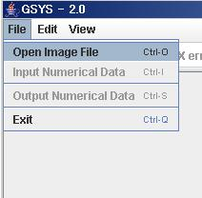
1) Get image
Choose “Open Image File” and zoom in the image file by “+” key as large as possible.

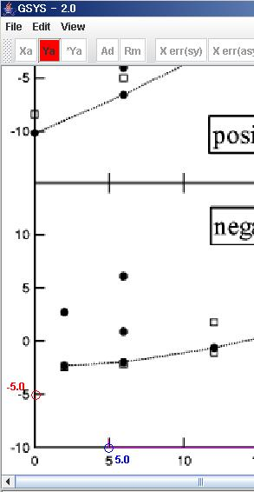

2) Set x- and y- axes
Click “Xa” and choose two points from x-axis of the image. Similarly click “Ya” and choose two points from y-axis of the image.

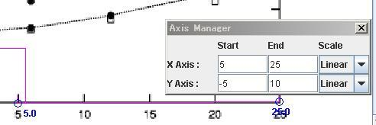
3) Give values on axes and scale
Give values of chosen points and scale of axes in the “Axis Manager” window.

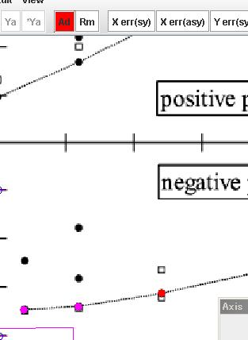

4) Mark symbols
Click “Ad” and mark symbols you want to digitize.

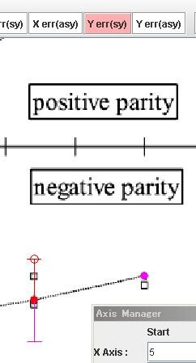
5) Add error bars to symbols
Click “Y err (sy)”, focus the symbol to which you want to add an error bar, and choose one side of the error bar. “F7” and “F8” keys are useful when you want to change focused symbol without mouse.

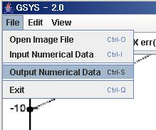

6) Output digitized data
Choose “Output Numerical Data”, set format and do sorting.

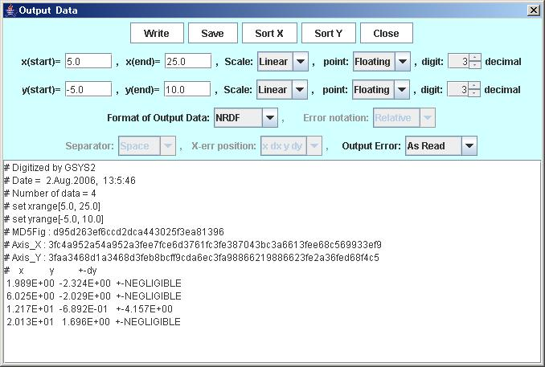

7) Write and save digitized data.
Click “Write” and “Save” to see and save digitized data.

