Japan Charged-Particle Nuclear Reaction Data Group

Division of Physics, Graduate School of Science

Hokkaido University

060-0810 Sapporo, JAPAN

E-mail: services@jcprg.org
Internet: http://www.jcprg.org/
Telephone +81(JPN)-11-706-2684
Facsimile +81(JPN)-11-706-4850

Memo CP-E/091 (Revised)

Date: | March 24, 2006
To: | Distribution
From: | OTSUKA Naohiko
Subject: | Dictionary 236 (Quantities) update

We compiled experimental data from T. Hashimoto et al., Nucl. Phys. A746 (2004) 330), which gives differential cross section with respect to excitation energy of residual nuclei ¹¹B (E_{exc}) integrated over incident center-of-mass energy range [E^{cm}_{min}, E^{cm}_{max}]:

in ⁴He(⁸Li,n)¹¹B reaction. We propose the following addition:

Dictionary 36 (Quantities)
,INT/DE,RSD B Integral over incident energy of energy spectrum of residual nucleus

Quantity | Type | Dimension | Reference | Subentry
,INT/DE,RSD | IDE? | B | T.Hashimoto et al.,  Nucl. Phys.A746(2004)330 | E1933.003

Distribution:
S. Babykina, CAJaD | J.H. Chang, KAERI | M. Chiba, JCPRG | F.E. Chukreev, CAJaD
S. Dunaeva, IAEA-NDS | Z.G. Ge, CNDC | O. Gritzay, KINR | A. Hasegawa, JAEA
H. Henriksson, NEA-DB | A. Kaltchenko, KINR | J. Katakura, JAEA | K. Katō, JCPRG
Y.O. Lee, KAERI | S. Maev, CJD | V.N. Manokhin, CJD | V. McLane, NNDC
A. Mengoni IAEA-NDS | M. Mikhaylyukova, CJD | C. Nordborg, NEA-DB | P. Obložinský, NNDC
Y. Ohbayasi, JCPRG | A. Ohnishi, JCPRG | N. Otuka, JCPRG | V. Pronyaev, CJD
D. Rochman, NNDC | O. Schwerer, IAEA-NDS | S. Tákacs, ATOMKI | S. Taova, VNIIEF
T. Tárkányi, ATOMKI | V. Varlamov, CDFE | M. Vlasov, KINR | M. Wirtz, IAEA-NDS
H.W. Yu, CNDC | V. Zerkin, IAEA-NDS | Y.X. Zhuang, CNDC | EXFOR, NEA-DB

Sample of coded entry (E1933.003)
T. Hashimoto et al., Nucl. Phys., A746 (2004) 330 Fig.4.

SUBENT E1933003 20060309 E193300300001
BIB 4 5 E193300300002
REACTION (2-HE-4(3-LI-8,N)5-B-11,,INT/DE,RSD) E193300300003
EN-SEC (E-EXC,5-B-11) Excitation enegy of 11B E193300300004
ERR-ANALYS (ERR-S) Statistical uncertainty E193300300005
STATUS (TABLE) Data (Fig.4, p333c in reference) received from E193300300006
T.Hashimoto by e-mail (2005.05.10) E193300300007
ENDBIB 5 0 E193300300008
COMMON 3 3 E193300300009
EN-CM-MIN EN-CM-MAX E-EXC-ERR E193300300010
MEV MEV MEV E193300300011
0.75 2.55 0.2 E193300300012
ENDCOMMON 3 0 E193300300013
DATA 3 40 E193300300014
E-EXC DATA ERR-S E193300300015
MEV MB MB E193300300016
-5.8 0.0 0.0 E193300300017
…
9.8 0.0 0.0 E193300300056
ENDDATA 42 0 E193300300057
ENDSUBENT 56 0 E193300399999
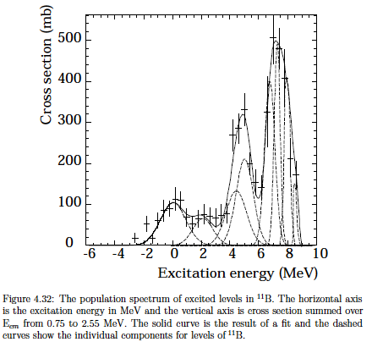

(Reproduced from the doctor thesis of T.Hashimoto, Tokyo Univ. of Science, 2004)

