Nuclear Data Section
International Atomic Energy Agency
P.O.Box 100, A-1400 Vienna, Austria

Memo CP-D/443

Date: 7 October 2005
To: Distribution
From: V. Zerkin

Subject: Concept of Procects in CINDA
(Working paper to NRDC meeting)

Attached is a working paper for the forthcoming technical NRDC meeting.

Distribution:

oblozinsky@bnl.gov
vml@bnl.gov
drochman@bnl.gov
nordborg@nea.fr
manokhin@ippe.obninsk.ru
samaev@obninsk.ru
Mmarina@ippe.obninsk.ru
blokhin@ippe.obninsk.ru
feliks@polyn.kiae.su
chukreev@polyn.kiae.su
S.Dunaeva@iaea.org
taova@expd.vniief.ru
varlamov@depni.sinp.msu.ru
chiba@earth.sgu.ac.jp
kato@nucl.sci.hokudai.ac.jp
ohnishi@nucl.sci.hokudai.ac.jp
ohbayasi@meme.hokudai.ac.jp
yxzhuang@iris.ciae.ac.cn
gezg@iris.ciae.ac.cn
hongwei@iris.ciae.ac.cn
tarkanyi@atomki.hu
stakacs@atomki.hu
katakura.junichi@jaea.go.jp
vlasov@kinr.kiev.ua
kaltchenko@kinr.kiev.ua
ogritzay@kinr.kiev.ua
yolee@kaeri.re.kr
jhchang@kaeri.re.kr
ohtsuka@nucl.sci.hokudai.ac.jp
A.Mengoni@iaea.org
m.wirtz@iaea.org
schwerer@iaeand.iaea.org
v.zerkin@iaea.org
henriksson@nea.fr
exfor@nea.fr

Concept of Projects in CINDA
WP 2005-21

V.Zerkin, IAEA-NDS

Information in CINDA is presented by Lines which are united in Blocks. Blocks are defined as unique combination of (Target, Reaction, Quantity, Lab, BlockNo). One of the major parameter in the Line (and important for us now) is Reference. BlockNo is assigned by a Compiler when s/he wants to separate a works which done in the same Lab but for some reasons have to be presented separately. (The reason can be: another equipment, purpose of experiment, method of obtaining results, time, etc.) This structure can be presented as nested information (see Present schema).

The same Reference can appear in several Blocks, this means that the work behind all these Blocks was done by (almost) the same authors, most likely using the same methodology and has other similarity. So, the number of Blocks have something common in background (at least from the view point of Compiler which united publications into each Block), but being stored in the present structure they are not related to each other and do not have a visible connection. As result, the CINDA compilation is a complex thing: the observation of the data in database is difficult, assignment of the BlockNo is a magic, Comments are often repeated, and whole process is not conceptually clear and difficult for understanding, especially by a new compiler.

Lets look to the matter from another direction. Usually, a group of authors is doing the work under a PROJECT (it can be a project in one Lab or in inter-Lab project) with some background, purpose, equipment, method, etc. They publish results in several places (Lab-reports, conferences, journals, books, etc.), which can have various data for several reactions. (In some sense, PROJECT is similar to ENTRY in EXFOR.) Obviously, if we introduce an essence <Project> and restructure our schema we can have some advantages:
- Easier to observe information in CINDA: Blocks (=Reaction-codes) are grouped under Publication (Reference);
- Easier to deal with blocking (to define whether or not a publication should go to a new Project)
- Usage of XML: viewers (Internet Explorer: see Fig.3), editors, no limits, “industrial standard”, etc.

At present CINDA Projects can be “calculated” on top of existing CINDA relational database. Software is written. For now, features working with Projects are (and will probably be) included to the CD-ROM “EXFOR-CINDA for Windows” with MS-Access database and retrieval system.

The Project concept with connection to XML format and related software, compilation process, retrieval and presentation is under development at NDS.

CINDA
{
Block-1: (Target, Reaction, Quantity, Lab, BlockNo)
{
Line-1: Line-1-info, Reference-1;
Line-2: Line-2-info, Reference-2;
. . . . . . . .
Line-n: Line-n-info, Reference-n
}
Block-2: (Target, Reaction, Quantity, Lab, BlockNo)
. . . . . . . .
Block-m: (Target, Reaction, Quantity, Lab, BlockNo)
}

Present schema

CINDA
{
Project-1: (Lab, Area, ProjectNo)
{
Reference-1 (Code)
{
Block-1: (Target, Reaction, Quantity)
{
Line-1: Line-1-info;
Line-2: Line-2-info;
. . . . . . .
Line-n: Line-n-info;
}
Block-2: (Target, Reaction, Quantity)
. . . . . . . .
Block-m: (Target, Reaction, Quantity)
}
Reference-2 (Code)
. . . . . . . . . .
Reference-k (Code)
}
Project-2: (Lab, Area, ProjectNo)
. . . . . . . .
Project-t: (Lab, Area, ProjectNo)
}

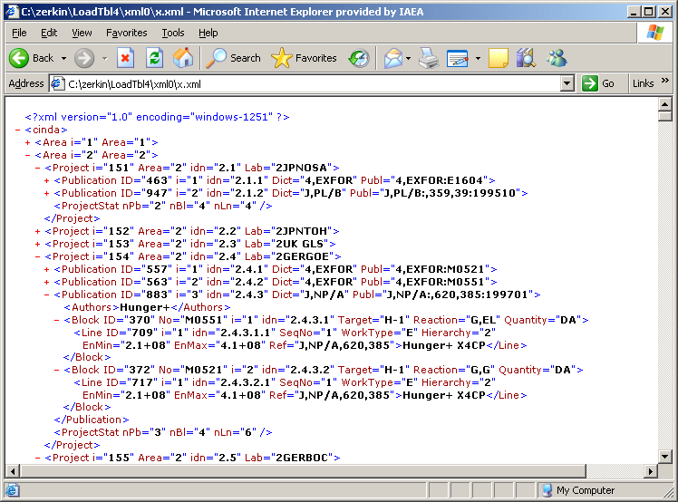
Proposed schema
Example: XML in IE

