NATIONAL NUCLEAR DATA CENTER
Bldg. 197D
Brookhaven National Laboratory
P. O. Box 5000
Upton, NY 11973-5000, U.S.A.

Telephone: (516)344-5096
FAX: (516)344-2806

Memo CP-C/379

DATE: September 21, 2006
TO: Distribution
FROM: P. Oblozinsky, D. Rochman
SUBJECT: NNDC Progress Report (October 2004 – September 2006)

NNDC Staff

Since the last full NRDC meeting in October 2004, the following personnel changes took place at the NNDC:
- Vicki McLane retired in December 2004, she was replaced by Dimitri Rochman (formerly at LANL), who joined the NNDC in November 2004.
- Charlie Dunford retired in June 2005. His position was not filled-in due to budgetary constraints.

The NNDC has 12.6 FTE staff (full-time equivalent). This includes 9 PhD physicists, 1 computer professional, 2 support staff, and 1 secretary (0.6 FTE).

EXFOR Compilations

Our nuclear reaction compilation was done regularly and we kept adding experimental data to the EXFOR (CSISRS) library continuously. The last TRANS file for neutron-induced reaction was #1340 and the last TRANS file for charge-particle induced reaction was C077. Gamma-induced reactions were also compiled with two TRANS files (L009).

Over the period of October 2004 – September 2006, we added a total of 543 new entries to EXFOR, including
- 180 neutron-induced reactions,
- 337 reactions induced by light charged-particles, and
- 26 photonuclear reactions.

Development of the ENDF/B-VII.0 Library

The NNDC continued to be heavily involved in the development of the new ENDF/B-VII.0 library. This includes active contribution to neutron cross-section evaluations primarily in the fission product mass range (70 new evaluations), entirely new evaluations for the decay data library (3,830 nuclides), database management and web service.

The schedule for testing and release of ENDF/B-VII.0 is as follows:
- April 2006 Beta2 testing version released
- June 2006 CSEWG validation meeting at BNL
- September 2006 Beta 3 testing version released
- November 2006 CSEWG annual meeting at BNL
- December 2006 ENDF/B-VII.0 library officially released

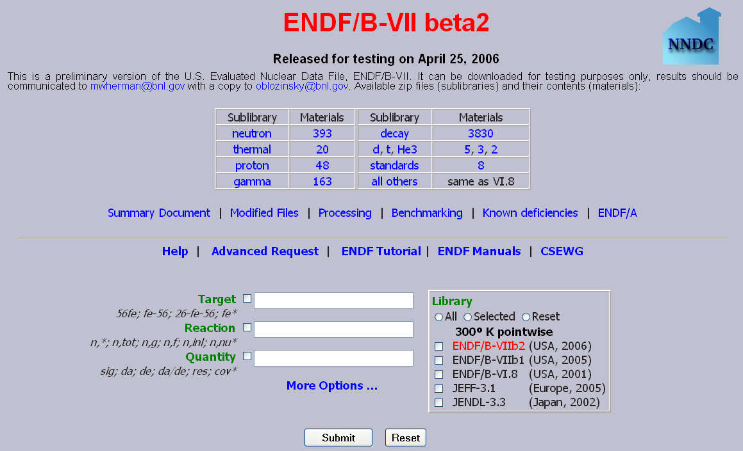

Fig.1. The NNDC webpage, with direct access to 14 sublibraries of ENDF/B-VII.0

Web Service and Communication with Users

The number of data retrievals from the NNDC web service continued to grow rapidly. Since April 2004, when we launched the new relational database management system coupled to new hardware and new web service, our retrieval statistics almost tripled. We are expecting to reach 1 million retrievals per year in 2006.

Although the demand for nuclear reaction services is relatively small compared to nuclear structure services, combined EXFOR and ENDF retrievals grew in the last year by about 40% compared to the previous year. Demand for CINDA continues to be marginal and represents less than 0.5% of all data retrievals.

We are devoting our time both to neutron and charge-particle reaction compilation activities, with priorities driven by the users’ needs. Our contact with users is maintained primarily by the open EXFOR contact area on the NNDC website, www.nndc.bnl.gov/exfor.

In early 2005, we created the “Recent Comments on CSISRS/EXFOR” webpage, www.nndc.bnl.gov/exfor3/compilations/web_emails.html. Since then, users from many countries, mostly from Europe and northern America, have sent their comments and suggestions to the NNDC. A total of 66 e-mail exchanges were presented on this web page, but some more exchanges were realized and not made publicly available. In general, we respond to users within 1 day after receiving a question or comment.

A special effort was devoted to the analysis of the EXFOR retrieval system. Based on this analysis, our website was redesigned in February 2006, with positive impact on retrieval statistics.

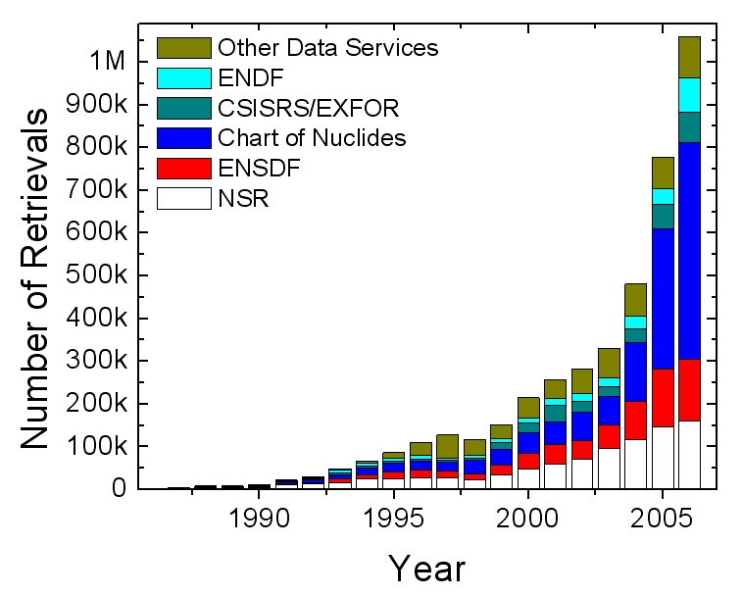

Fig.2. Data retrievals statistics for the NNDC web service. The year 2006 represents projection based on the actual 9 months value.

Distribution

vml@bnl.gov  drochman@bnl.gov  manokhin@ippe.obninsk.ru  maev@ippe.obninsk.ru  may@obninsk.ru  Mmarina@ippe.obninsk.rug  blokhin@ippe.obninsk.ru  feliks@polyn.kiae.su  chukreev@polyn.kiae.su  S.Dunaeva@iaea.org  taova@expd.vniief.ru  varlamov@depni.sinp.msu.ru  kato@nucl.sci.hokudai.ac.jp  ohnishi@nucl.sci.hokudai.ac.jp | gezg@iris.ciae.ac.cn  hongwei@iris.ciae.ac.cn  tarkanyi@atomki.hu  stakacs@atomki.hu  vlasov@kinr.kiev.ua  ogritzay@kinr.kiev.ua  ohtsuka@nucl.sci.hokudai.ac.jp  m.wirtz@iaea.org  m.lammer@iaea.org  v.pronyaev@iaea.org  v.zerkin@iaea.org  henriksson@nea.fr  exfor@nea.fr  schwerer@iaea.or.at

