NATIONAL NUCLEAR DATA CENTER
Bldg. 197D
Brookhaven National Laboratory
P. O. Box 5000
Upton, NY 11973-5000, U.S.A.

Telephone: (516)344-5096
FAX: (516)344-2806

Memo CP-C/375

DATE: August 3, 2006
TO: Distribution
FROM: D. Rochman
SUBJECT: Proposal for the generation of Bibtex citations from CSISRS

It recently occurred to us that some of the major publishers (APS, IoP, Elsevier) are offering the possibility to download the reference of a given publication. The available formats are suitable to be included in a Latex template, such as Bibtex. The advantage for a user is that when writing a publication, he will not have to type by hand the reference that he would like to use, but he can just download it in the proper format and include it in his Latex file.

An example of such Bibtex reference is given in the following:
(http://link.aps.org/doi/10.1103/PhysRevC.70.044610)

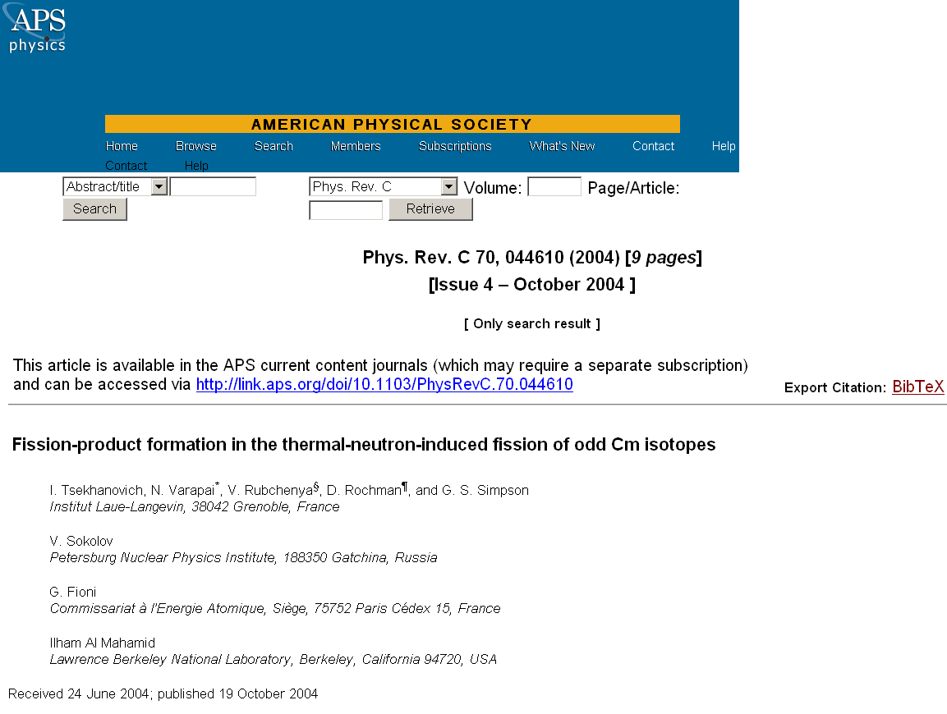

Bibtex Format:
@article{tsekhanovich:044610,
author = {I. Tsekhanovich and N. Varapai and V. Rubchenya and D. Rochman and G. S. Simpson and V. Sokolov and G. Fioni and Ilham Al Mahamid},
collaboration = {},
title = {Fission-product formation in the thermal-neutron-induced fission of odd Cm isotopes},
publisher = {APS},
year = {2004},
journal = {Physical Review C (Nuclear Physics)},
volume = {70},
number = {4},
eid = {044610},
numpages = {9},
pages = {044610},
keywords = {nuclear charge; neutron-nucleus reactions; nuclei with mass number 220 or higher; nuclear mass; fission; fission products},
url = {http://link.aps.org/abstract/PRC/v70/e044610}
}

All the information contained in the Bibtex reference file is already entered in the EXFOR file. We propose that an automatic procedure is written to create Bibtex file for old and new EXFOR compilations. Then, the Bibtex file would be in an “Output format” such as the existing “EXFOR”, “Bibliography” or “Plot” options.

Distribution:

vml@bnl.gov  drochman@bnl.gov  manokhin@ippe.obninsk.ru  maev@ippe.obninsk.ru  may@obninsk.ru  Mmarina@ippe.obninsk.rug  blokhin@ippe.obninsk.ru  feliks@polyn.kiae.su  chukreev@polyn.kiae.su  S.Dunaeva@iaea.org  taova@expd.vniief.ru  varlamov@depni.sinp.msu.ru  kato@nucl.sci.hokudai.ac.jp  ohnishi@nucl.sci.hokudai.ac.jp | gezg@iris.ciae.ac.cn  hongwei@iris.ciae.ac.cn  tarkanyi@atomki.hu  stakacs@atomki.hu  vlasov@kinr.kiev.ua  ogritzay@kinr.kiev.ua  ohtsuka@nucl.sci.hokudai.ac.jp  m.wirtz@iaea.org  m.lammer@iaea.org  v.pronyaev@iaea.org  v.zerkin@iaea.org  henriksson@nea.fr  exfor@nea.fr  schwerer@iaea.or.at

