Japan Nuclear Reaction Data Centre (JCPRG)
Faculty of Science
Hokkaido University
060-0810 Sapporo, JAPAN

E-mail: services@jcprg.org
Internet: http://www.jcprg.org/
Telephone +81(JPN)-11-706-2684
Facsimile +81(JPN)-11-706-4850

Memo CP-E/145
Date: | April 22, 2010
To: | Distribution
From: | SUZUKI Ryusuke
Subject: | New version of JCPRG digitizer (GSYS2.4)

A new version of the digitizing software “GSYS2.4” becomes available at the JCPRG website as informed in the last NRDC meeting. It should work in computers where the Java Runtime Environment is executable (Windows, Linux, FreeBSD, Mac OS X, etc.).

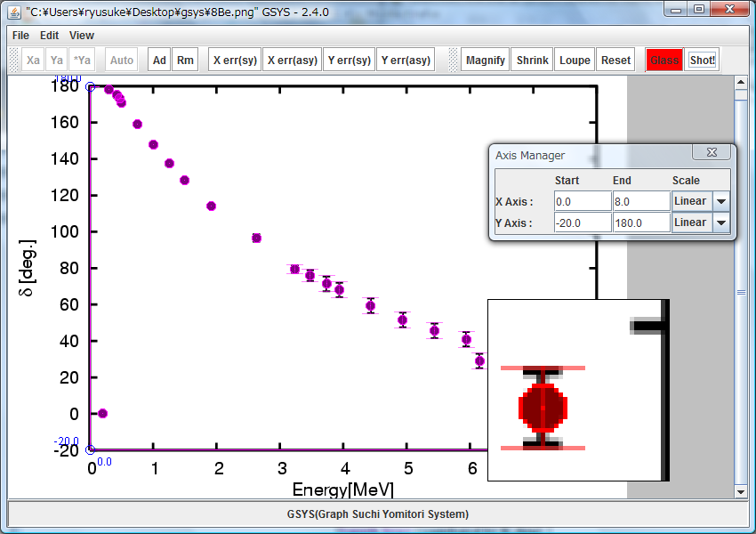

Fig. 1 Gsys2.4 Screenshot.

What’s new?
1) Drag-and-drop feature
2) Transparency of the points and lines
3) Addition of the point shape
4) Loupe function
5) Magnifying glass function
6) Automatically point recognition function
7) Snapshot function
8) Some other improvements
Install and uninstall:
1) Install Java Runtime Environment (JRE) Ver. 1.4 or later from http://java.com/.
(Maybe it has been already installed in your computer.)
2) Download “Gsys2.4.0.jar” from http://www.jcprg.org/gsys/2.4/.
3) Double-click “Gsys2.4.0.jar” icon or type “java –jar Gsys2.4.0.jar” from command line.
4) If you want to uninstall GSYS2.4, delete the file “Gsys2.4.0.jar”.

New features:
1) Drag-and-drop feature
Drag and drop
a) Figure
Figure is opened
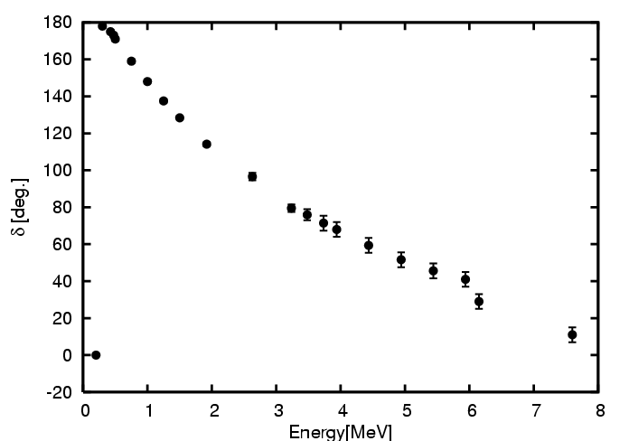
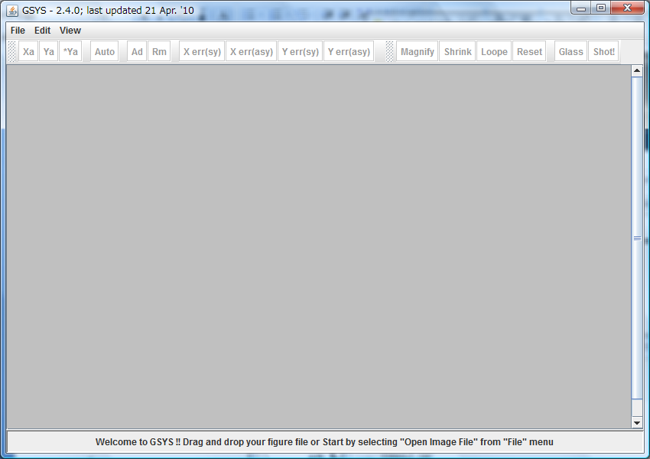
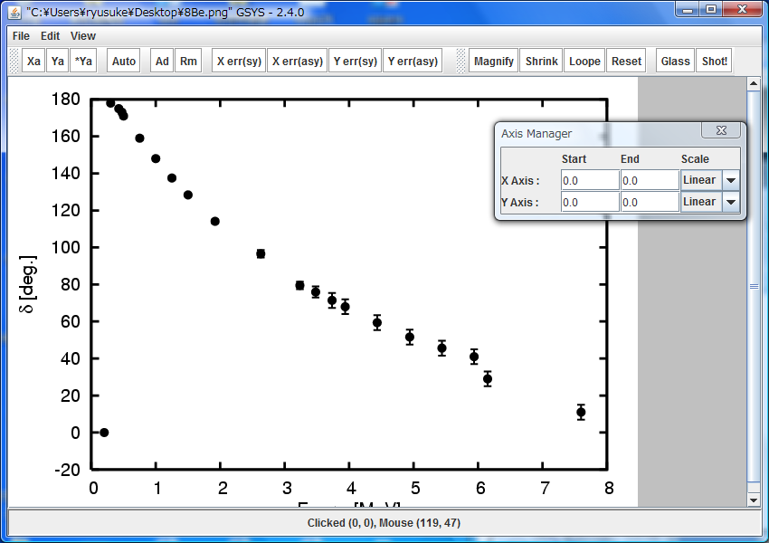

Drag and drop
b) Numerical data
Numerical data is plotted
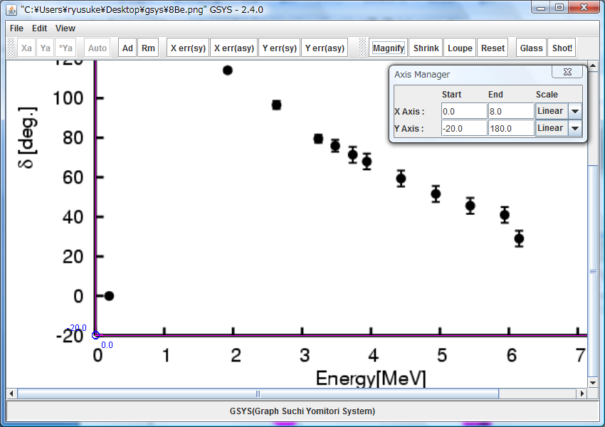
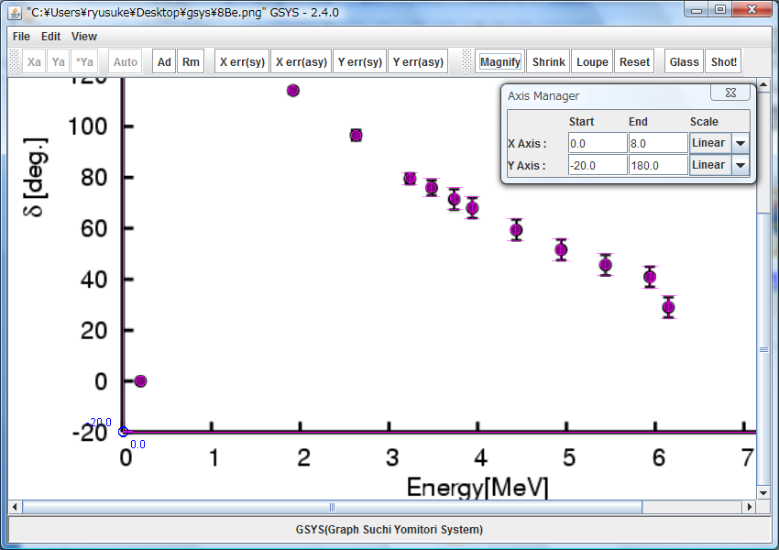
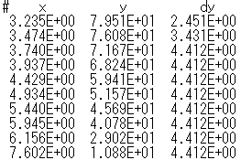


2) Transparency of the points and lines.






3) Some point shapes (square, triangle, diamond) are added in addition to the circle.

4) Loupe function: Click Loupe button, and drag the area to be enlarged.
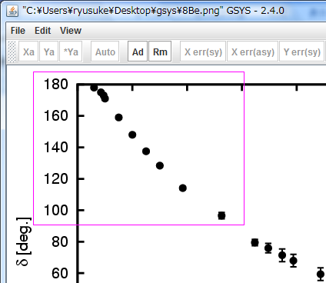
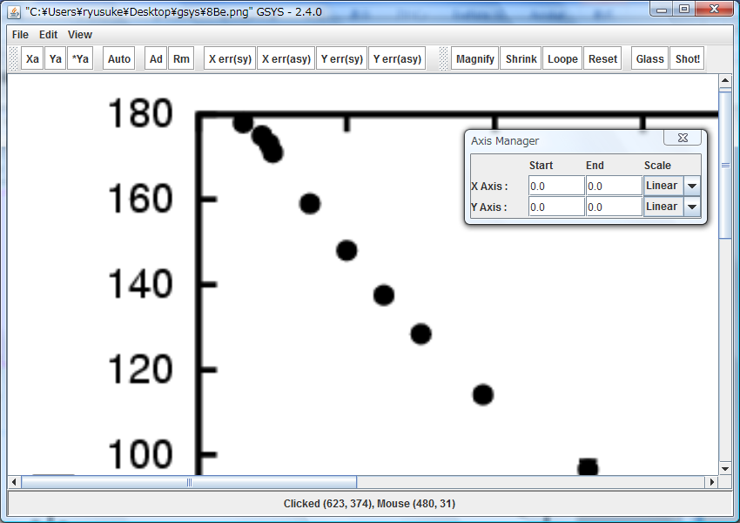

5) Magnifying Glass function: Click Glass button, and click on the figure. The glass window will appear. You can move the window by dragging. Usual operation(add point, correct the marker position, and so on) can be performed on the glass window.
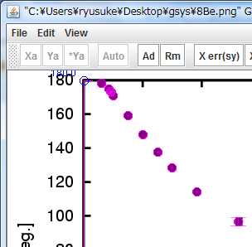
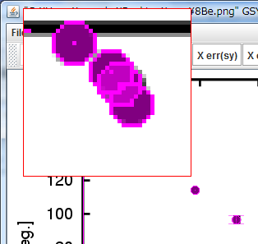

6) Automatically point recognition function: In the point addition mode, the maker on the figure is automatically recognized and the position is automatically corrected.
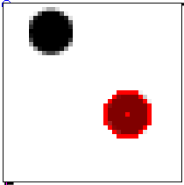
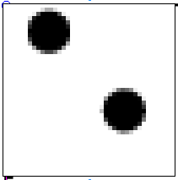

Click
Marked correctly!

7) SnapShot function
Click Shot ! button, then you can get the screenshot as shown in Fig. 4.

References
[1] CP-E/099: general usage (GSYS2).
[2] CP-E/106: Automatic axis and scale detection in GSYS2.2.

Distribution:
S. Babykina, CAJaD | A. Blokhin, CJD | M. Bossant, NEA-DB | J.H. Chang, KAERI
M. Chiba, JCPRG | S. Dunaeva, NDS | E. Dupont, NEA-DB | S. Ganesan, BARC
Z.G. Ge, CNDC | O. Gritzay, UkrNDC | A. Hasegawa, NEA-DB | M. Herman, NNDC
A. Kaltchenko, UkrNDC | J. Katakura, JAEA | K. Katō, JCPRG | Y.O. Lee, KAERI
S. Maev, Obninsk | V.N. Manokhin, CJD | V. McLane, NNDC | R. Forrest, NDS
M. Mikhaylyukova, CJD | C. Nordborg, NEA-DB | P. Obložinský, NNDC | N. Otuka, NDS
V. Pronyaev, CJD | J. Roberts, NDS | N. Soppera, NEA-DB | O. Schwerer, NNDC
S. Tákacs, ATOMKI | S. Taova, VNIIEF | T. Tárkányi, ATOMKI | V. Varlamov, CDFE
M. Vlasov, UkrNDC | L. Vrapcenjak, NDS | S.C.Yang, KAERI | H.W. Yu, CNDC
V. Zerkin, NDS | Y.X. Zhuang, CNDC | JCPRG Distribution

